**Team B - Ekathra**

# PROJECT MANAGEMENT PLAN

**Project Name: Traffic Modelling System**

**Team Name: Ekathra Prepared date: 2/17/2017**

**Project Overview:**

The traffic modeling system is a simulation system through which different types of road would be attached to simulate the behavior of traffic. There are several components like roundabout, 2-way road, 4-way, signals, and T-junction so that they would act as network of roads. To start the simulation, user need to input some parameters such as: number of cars per minute, reaction rate.

**Project Deliverables:**

We need to deliver a working standalone applications meeting the requirements specifications and functionality of the client.

The following need to be delivered:

* 1. Standalone application
  2. User manual
  3. Installation manual
  4. Requirements document
  5. Software requirements specifications
  6. Test cases
  7. Issues document.

**Client Name:**​ Dr. Michael Oudshoorn

**Project Organization:**

**Organizational Structure:** ​We are using the functional structure like everyone will be reporting to their supervisor respectively.

**Organizational boundaries and interfaces:** ​Each task supervision is assigned to a member in the team as their responsibility to make them active and perform leadership.

* **Project responsibilities:** 
  + Every deliverable of the project should be completed within the time and need to get approval from the client in the given time.
  + Client should take the responsibility in supporting the team by providing sufficient amount of budget in completing the project.
  + There should not be any conflicts between the team and team jellness should be maintained throughout the entire project.
* **Managerial process:**
* The goal of the project should be achieved with the collaboration of all the members with in the team in time.
* The project should be monitored to handle the changes, the project should be reviewed on a weekly basis and deliverable should be formally accepted by the sponsor.
* This project contain 7 members required to do the project.
* **Technical Processes:**
* This deals with the tools and techniques required to do the project. Every organization will select the tools in the initial phase of the project to complete it with in time.
* Here we are using tools Eclipse, MS office and NetBeans.

**Budget Allocation:**

We are measuring the budget in terms of time spent on the project. Each person will spend about 2 hours each day in weekdays and in weekends we will have team meetings of duration 2 hours. We will be attending the client meeting of 1 hour in a particular week which makes a total of 15 hours. For each person

**How we calculated hours:** Our estimation for this project would 8000 approx lines of code. We are considering 8000 lines of code through some expert reviews. We have discussed lines of code with some employees and came to get this figure through them.

Avg. person writes 115 lines of code per week

Therefore a person requires 10 hours of work per week and 5 hours of meeting. So the total would be 15 hours of work per week.

Weekdays: 5 X 2 = 10

Weekend team meetings: 2 X 2 = 4

Client meeting: 1 X 1 = 1

Total: 15 hours

So we are spending about 15 hours per person per week which makes a total of 15X7 = 105 hours per week per team. So the total budget of the project is 85X24 = 2520 (26 is the total number of weeks in both GDP 1 and GDP 2).

Per week per person: 15 X 1 = 15

Per week per team: 15 X 7 = 105

Total hours per team: 85 X 26 = 2730 hours.

Here 26 is the total number of weeks the project is going to take.

**Schedule:**

The project started on 09/01/16 and it will be completed by 04/10/17 and detailed information of the schedule will be in schedule management plan.

**Roles and Responsibilities**

| **S.N o** | **Name** | **Role** | **Responsibilities** |
| --- | --- | --- | --- |
| 1 | Rupanandha Moori | Primary Contact | He is the primary contact with client. He will represent the whole team and communicates with client regarding project requirements, progression, changes and completion. |
| 2 | Manikanta Nomula | Communications  & Documentation  Management | He is responsible to maintain communication and documentation management and it includes updating all changes and tracking project progression in different versions. |
| 3 | Rama Naveen Kommuri | Quality & Testing  Management | He is responsible to maintain quality throughout the SDLC process and to deliver effective output on time. To achieve the qualitative deliverables, testing plays a vital role. He will be responsible to test each module in the project. |
| 4 | Ashwini Cherukuri | Data Management | She will take care of the collecting, storing and managing data in database and connecting data with front end system to update data which is entered by client. She would be responsible for managing data for our project. Including database connectivity, database designing, data mining etc. |
| 5 | Vamsy Chowdary Bobba | Issues  Management | He would be responsible to track all the issues in the project duration which may relate to internal staff and make sure to work the project as smooth. |
| 6 | Sahil  Nokhwal | Requirements Management | He will gather requirements from client and handle the changes in requirements as per the progress of project. He will also analyze, track and prioritizing the requirements. |
| 7 | Laxmi Sai Teja Naraharasetty | Client  Management | He takes the responsibility of meeting, getting requirements from client and also giving updates to the client. |

**Scope Management Plan:**

**Preparation of detailed project scope statement:**

The detailed scope statement is developed by identifying the main factors that influence the development of the project which includes developing project charter, identifying stakeholders, identifying requirements etc.

**Creation of WBS:**

The entire project was divided into four main parts from where subtasks are divided in it in order to complete the project with in time and to determine project hierarchy.

The major deliverables of the project is decomposed into subtasks and then further to the smaller work packages.

**Maintainenance and approval of WBS:**

Each task in the WBS is assigned to every member of the project and group meetings will be held by the project manager for every four days of the project. The entire work in the WBS is the sum of the WBS items below it. Every WBS item is responsible for only one person in the team. Project manager will inspect the every task in the project and frequently gets the updates from the team members.

**Obtaining formal acceptance of the completed project deliverables:**

After the completion of the project deliverables there will be sponsor inspection for the acceptance of the project deliverables. Each project deliverable will be submitted to the sponsor by the project manager where the sponsor will inspect the deliverable and approves it.

**Controlling requests for changes to the project scope:**

If any changes are to be done in the project, team members will inform to the project manager then project manager will pass those change requests to the top management and gets the approval and project manager will manage the required changes in the project scope.

**Old work breakdown Structure:**

|  |  |  |  |  |  |
| --- | --- | --- | --- | --- | --- |
| Task Mode | Task Name | Duration | Start | Finish | Predecessors |
| **Manually Scheduled** | **1.0  Architecture Design Phase** | **11 days** | **Mon 1/9/17** | **Mon 1/23/17** |  |
| Auto Scheduled | 1.1 Identify Architecture Objectives | 3 days | Mon 1/9/17 | Wed 1/11/17 |  |
| Auto Scheduled | 1.2 Key Scenarios. | 2 days | Thu 1/12/17 | Fri 1/13/17 | 2 |
| Auto Scheduled | 1.3 Application Overview. | 2 days | Mon 1/16/17 | Tue 1/17/17 | 3 |
| Auto Scheduled | 1.4 Key Issues | 2 days | Wed 1/18/17 | Thu 1/19/17 | 4 |
| Auto Scheduled | 1.5 Candidate Solutions. | 2 days | Fri 1/20/17 | Mon 1/23/17 | 5 |
| **Auto Scheduled** | **2.0 Car generation development** | **15 days** | **Tue 1/24/17** | **Mon 2/13/17** | **1** |
| Auto Scheduled | 2.1 Default values loading | 1 day | Tue 1/24/17 | Tue 1/24/17 |  |
| **Auto Scheduled** | 2.2 Car Properties | 8 days | Wed 1/25/17 | Fri 2/3/17 | **8** |
| Auto Scheduled | 2.2.1 Car Speeding | 2 days | Wed 1/25/17 | Thu 1/26/17 |  |
| Auto Scheduled | 2.2.2 Acceleration and deceleration | 2 days | Fri 1/27/17 | Mon 1/30/17 | 10 |
| Auto Scheduled | 2.2.3 Direction Selection | 2 days | Tue 1/31/17 | Wed 2/1/17 | 11 |
| Auto Scheduled | 2.2.4 Signaling | 2 days | Thu 2/2/17 | Fri 2/3/17 | 12 |
| Auto Scheduled | 2.3 Integration of Car Generator | 3 days | Mon 2/6/17 | Wed 2/8/17 | 9 |
| Auto Scheduled | 2.4 Module Testing | 3 days | Thu 2/9/17 | Mon 2/13/17 | 14 |
| Auto Scheduled | Milestone 1 | 0 days | Mon 2/13/17 | Mon 2/13/17 | 15 |
| **Auto Scheduled** | **3.0 Roads** | **15 days** | **Tue 2/14/17** | **Mon 3/6/17** | **7** |
| Auto Scheduled | 3.1 T Junction Generation | 3 days | Tue 2/14/17 | Thu 2/16/17 |  |
| Auto Scheduled | 3.2 Roundabouts Generation | 3 days | Fri 2/17/17 | Tue 2/21/17 | 18 |
| Auto Scheduled | 3.3 4-Stop Sign Road Generation | 3 days | Wed 2/22/17 | Fri 2/24/17 | 19 |
| Auto Scheduled | 3.4 2-Stop Sign Generation | 3 days | Mon 2/27/17 | Wed 3/1/17 | 20 |
| Auto Scheduled | 3.5 Module Testing | 3 days | Thu 3/2/17 | Mon 3/6/17 | 21 |
| **Auto Scheduled** | **4.0 Car Garbage Selection** | **8 days** | **Tue 3/7/17** | **Thu 3/16/17** | **17** |
| Auto Scheduled | 4.1 Development | 5 days | Tue 3/7/17 | Mon 3/13/17 |  |
| Auto Scheduled | 4.2 Module Testing | 3 days | Tue 3/14/17 | Thu 3/16/17 | 24 |
| Auto Scheduled | Milestone 2 | 0 days | Thu 3/16/17 | Thu 3/16/17 | 25 |
| **Auto Scheduled** | **5.0 Roads Integration** | **13 days** | **Fri 3/17/17** | **Tue 4/4/17** | **23** |
| Auto Scheduled | 5.1 Development | 5 days | Fri 3/17/17 | Thu 3/23/17 |  |
| Auto Scheduled | 5.2 Integration | 4 days | Fri 3/24/17 | Wed 3/29/17 | 28 |
| Auto Scheduled | 5.3 Testing | 4 days | Thu 3/30/17 | Tue 4/4/17 | 29 |
| **Auto Scheduled** | **6.0 User testing** | **4 days** | **Wed 4/5/17** | **Mon 4/10/17** | **27** |
| Auto Scheduled | 6.1 Client presentation | 1 day | Wed 4/5/17 | Wed 4/5/17 |  |
| Auto Scheduled | 6.2 Feedback collection | 1 day | Thu 4/6/17 | Thu 4/6/17 | 32 |
| Auto Scheduled | 6.3 Improvements | 1 day | Fri 4/7/17 | Fri 4/7/17 | 33 |
| Auto Scheduled | 6.4 submission | 1 day | Mon 4/10/17 | Mon 4/10/17 | 34 |

**Gantt chart:**

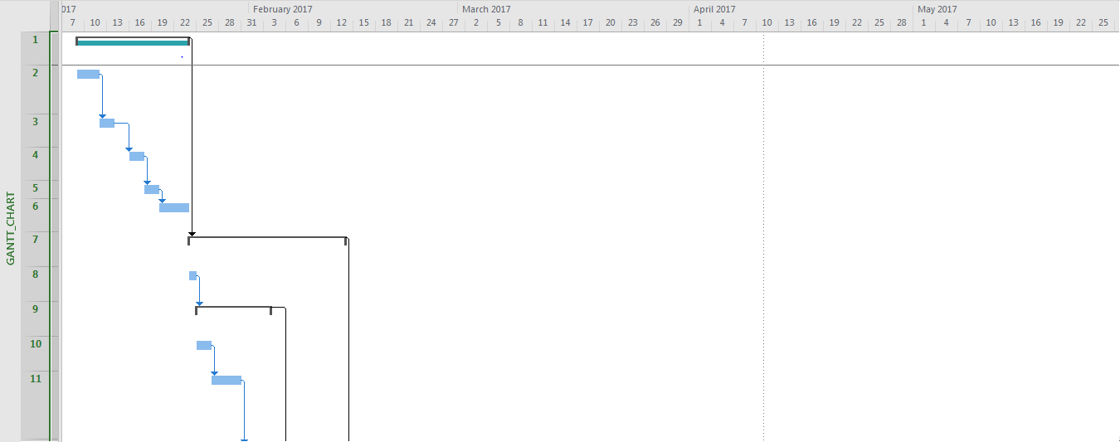

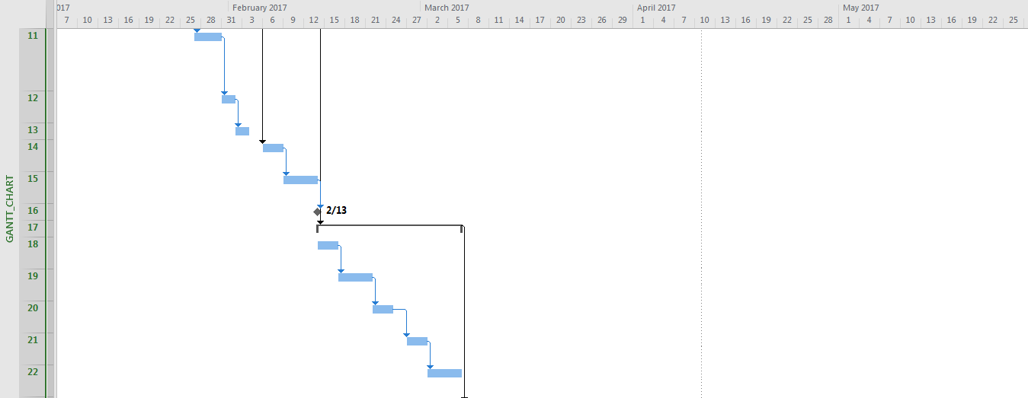

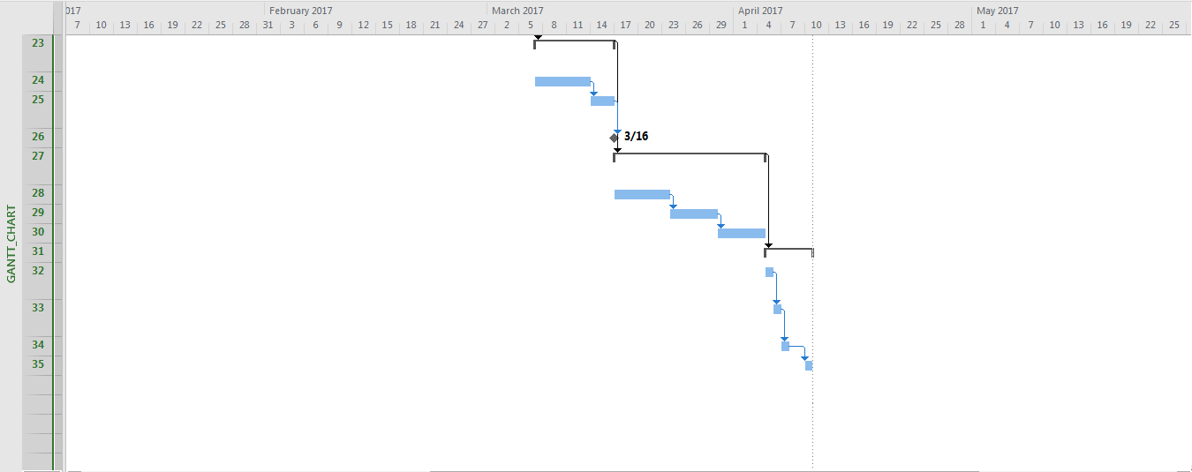

**Change Management Plan:**

In this project there may be changes to the scope in the middle of the development phase, those changes must be approved and implemented through this document.

|  |  |  |  |  |  |  |  |
| --- | --- | --- | --- | --- | --- | --- | --- |
| **Project Information** | | | | | | | |
| **Project Title:** | | |  | | | | |
| **Project Manager:** | | | | | | | |
| **Section 1: Change Request** | | | | | | |
| **Requestor Name:**  **Requestor Phone:** | | **Date of Request:** | | **Change Request Number:**  *Supplied by (PM)* | | |
| **Item to be Changed:** | | | | **Priority:** | | |
| **Description of Change:** | | | | | | |
| **Estimated Cost & Time:** | | | | | | |
| **Section 2: Change Evaluation** | | | | | | | |
| **Evaluated by:** | | | **Work Required:** | | | | |
| **What is Affect:** | | |
| **Impact to Cost, Schedule, Scope, Quality, and Risk:** | | | | | | | |
| **Section 3: Change Resolution** | | | | |  |
| **Accepted Rejected** | **Approved by (Print):** | | **Signature:** | | **Date:** |
| **Comments:** | | | | | |
| **Section 4: Change Tracking** | | | | |  |
| **Completion Date** | **Completed by (Print):** | | **Signature:** | | **Date:** |

## Quality Management Plan

Verification and validation plan:

* In this it is ensured that every phase is tested properly and fully working application is given to the client.
* Ensures that any module that are found with defects are put through the process again.
* Ensures that reviews are done properly.
* Ensures that product is working as intended meeting all requirements.

Quality Assurance plan:

* Ensure that any Quality Assurance issues found with the source code, database structure and hardware are handled in a proper manner.
* Ensure that the problems once handled cannot occur again.
* Ensures that problems are documented properly.
* Ensures that the product is functioning as it is intended.

Reviews and audits:

* Getting the Status of the project from each and every phase of the project.
* Asses the overall status of the project.
* Ensures that standards are followed in every process of development.

Problem Resolution plan:

* Ensure that any defect or problem raised during the development is handled in a correct manner.
* Ensures that defects are documented properly.
* Ensures that defects are re-tested and all associated modules are re-tested.

## Risk Management Plan

Risk Management plan:

1. In this phase the risks associated with the project are managed. Also, actions or measures are described to prevent or to reduce the risks.
2. Loss of key personnel, could involve personnel being recruited to other employer or project, or the long term illness of the individual i.e., Risk associated with Human Resources.
3. Risk associated with work.
4. Risk associated with time and budget of the project.

### Risk Mitigation strategies

|  |  |  |
| --- | --- | --- |
| **S. No.** | **Risk Category** | **Risk Mitigation Strategy** |
| 1 | Change in requirements. | Requirements should be documented every time and need to get signed from the client. |
| 2 | Project Integration Risk | Team members should be involved at the time of integration and proper testing should be done at that time. |
| 4 | Scope Risk | Have an experienced Project Manager prepare the scope management plan |
| 5 | Stakeholder Risk | Stakeholders should be involved in every phase of the project and get clear understanding for the project. |
| 6 | Communication Risk | Proper communication should be maintained with every member of the team  Every team member should be involved in every phase of the project. |
| 7 | Time Risk | Team should follow specific time and meet the milestones accordingly.  There should be proper management on schedule to meet the deadlines. |
|  |  |  |
|  |  |  |

Updated Work Break Down structure with Roles and Responsibilities in GDP 2:

|  |  |  |  |  |  |  |  |
| --- | --- | --- | --- | --- | --- | --- | --- |
| Task Mode | Task Name | Duration | Start | Finish | Predecessors | Resource Names | Status |
| **Manually Scheduled** | **1.0  Architecture Design & support** | **20 days** | **Mon 1/9/17** | **Fri 2/3/17** |  | **Rupanandha Moori[50%],Ram Naveen[50%]** | **Complete** |
| Auto Scheduled | 1.1 Application analysis & overview | 10 days | Mon 1/9/17 | Fri 1/20/17 |  | Ram Naveen,Rupanandha Moori | Complete |
| Manually Scheduled | 1.2 Architecture and implementation objectives | 10 days | Mon 1/23/17 | Fri 2/3/17 | 2 | Rupanandha Moori,Ram Naveen | Complete |
| **Manually Scheduled** | **2.0 Car generation development** | **33 days** | **Mon 1/16/17** | **Wed 3/1/17** |  | **Mani Nomula [50%],Vamsi Bobba[50%]** | **Complete** |
| Auto Scheduled | 2.1 Default values loading | 6 days | Mon 1/16/17 | Mon 1/23/17 |  | Ashwini | Complete |
| **Manually Scheduled** | 2.2 Car Properties | 21 days | Tue 1/24/17 | Tue 2/21/17 | **5** |  | **Complete** |
| Auto Scheduled | 2.2.1 Car Speeding | 5 days | Tue 1/24/17 | Mon 1/30/17 |  | Vamsi Bobba,Mani Nomula | Complete |
| Auto Scheduled | 2.2.2 Acceleration and deceleration | 5 days | Tue 1/31/17 | Fri 2/10/17 | 5,7 | Ashwini,Teja Naraharishetty | Complete |
| Auto Scheduled | 2.2.3 Integration and unit,module testing | 4 days | Mon 2/6/17 | Fri 2/10/17 | 7,8 | Ram Naveen,Rupanandha Moori | Complete |
| Auto Scheduled | 2.2.4 Direction Selection | 7 days | Mon 2/6/17 | Tue 2/14/17 | 5,7,8 | Mani Nomula ,Vamsi Bobba | Complete |
| Auto Scheduled | 2.3 Integration of Car Generator | 3 days | Wed 2/22/17 | Fri 2/24/17 | 6 | Mani Nomula ,Vamsi Bobba | Complete |
| Auto Scheduled | 2.4 Integration and unit,module testing | 3 days | Mon 2/27/17 | Wed 3/1/17 | 11,5,7,8,10 | Ashwini,Ram Naveen | Complete |
| Auto Scheduled | 2.5 Milestone 1 | 0 days | Wed 3/1/17 | Wed 3/1/17 | 12,9 |  | Complete |
| **Manually Scheduled** | **3.0 Roads & roads integration** | **34 days** | **Mon 1/16/17** | **Thu 3/2/17** |  | Sahil Nokhwal[50%],Teja Naraharishetty[50%] | **Late** |
| Auto Scheduled | 3.1 Drag & Drop functionality | 8 days | Mon 1/16/17 | Wed 1/25/17 |  | Sahil Nokhwal | Late |
| Auto Scheduled | 3.2 Roundabouts Generation | 7 days | Mon 1/16/17 | Tue 1/24/17 |  | Teja Naraharishetty | Complete |
| Auto Scheduled | 3.3 2-Stop Sign Generation | 6 days | Thu 1/26/17 | Thu 2/2/17 | 15 | Sahil Nokhwal | Complete |
| Auto Scheduled | 3.4 4-Stop Sign Road Generation | 12 days | Fri 2/3/17 | Thu 3/9/17 | 17 | Sahil Nokhwal | Complete |
| Auto Scheduled | 3.5 T Junction Generation | 3 days | Mon 2/20/17 | Wed 2/22/17 | 17,15,18 | Teja Naraharishetty | Complete |
| Auto Scheduled | 3.6 Integration | 5 days | Fri 3/10/17 | Thu 3/16/17 | 15,18,16,17 | Sahil Nokhwal,Teja Naraharishetty | Complete |
| Auto Scheduled | 3.7 Unit and module testing | 9 days | Fri 3/17/17 | Wed 3/29/17 | 20 | Ashwini,Rupanandha Moori | Complete |
| Auto Scheduled | 3.8 Milestone 2 | 0 days | Wed 3/29/17 | Wed 3/29/17 | 21 |  | Complete |
| **Manually Scheduled** | **4.0 Series of main tasks** | **13 days** | **Thu 3/2/17** | **Mon 3/20/17** | **12** |  | **Complete** |
| Auto Scheduled | 4.1 Car acceleration and decceleration at stop signs | 3 days | Thu 3/2/17 | Mon 3/6/17 | 12 | Mani Nomula ,Vamsi Bobba,Ashwini,Ram Naveen,Rupanandha Moori,Sahil Nokhwal,Teja Naraharishetty | Complete |
| Auto Scheduled | 4.2 Car Collision Handling | 3 days | Tue 3/7/17 | Thu 3/9/17 | 24,12 | Sahil Nokhwal,Teja Naraharishetty,Ashwini,Mani Nomula ,Ram Naveen,Rupanandha Moori,Vamsi Bobba | Complete |
| Auto Scheduled | 4.3. Car Percentage distribution | 7 days | Fri 3/10/17 | Mon 3/20/17 | 25 | Ashwini,Mani Nomula ,Ram Naveen,Rupanandha Moori,Sahil Nokhwal,Teja Naraharishetty,Vamsi Bobba | Complete |
| Manually Scheduled | 4.4 Milestone 3 | 0 days | Tue 3/21/17 | Tue 3/21/17 | 26 |  | Complete |
| **Manually Scheduled** | **5.0 User,unit testing, and module testing & documentation** | **11 days** | **Mon 3/20/17** | **Mon 4/3/17** |  |  | **Complete** |
| Auto Scheduled | 5.1 Designing 2-D layout | 4 days | Mon 3/20/17 | Thu 3/23/17 | 25 | Ashwini,Mani Nomula ,Ram Naveen,Rupanandha Moori,Sahil Nokhwal,Teja Naraharishetty,Vamsi Bobba | Complete |
| Auto Scheduled | 5.2 Integration testing,Unit testing anddocumentation | 4 days | Fri 3/24/17 | Wed 3/29/17 | 29 | Ashwini,Mani Nomula ,Ram Naveen,Rupanandha Moori,Sahil Nokhwal,Teja Naraharishetty,Vamsi Bobba | Complete |
| Auto Scheduled | 5.3 Fixing Bugs for the code | 2 days | Thu 3/30/17 | Fri 3/31/17 | 30 | Ashwini,Mani Nomula ,Ram Naveen,Rupanandha Moori,Sahil Nokhwal,Teja Naraharishetty,Vamsi Bobba | Complete |
| Auto Scheduled | 5.4 Complete Project Testing | 3 days | Wed 3/29/17 | Mon 4/3/17 | 30 |  | On Schedule |
| Manually Scheduled | 5.5 Client acceptance (Milestone 4) | 0 days | Mon 4/3/17 | Mon 4/3/17 |  |  | Future Task |